**Lecture Note 8**

**Networks**

**P r o b l e m O n e:**

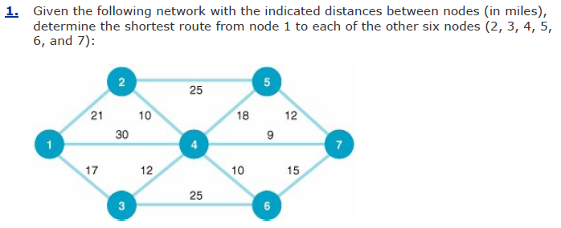

**P r o b l e m T w o:**

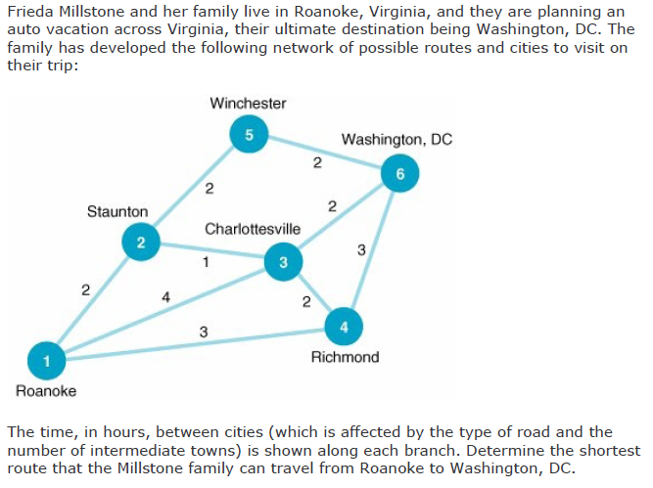

**P r o b l e m T h r e e:**

**The Hylton Hotel has a limousine van that transports guests to various business and tourist locations around the city. The following network indicates the different routes the limousine could follow from the hotel at node 1 to the nine locations (nodes 2 through 10):**

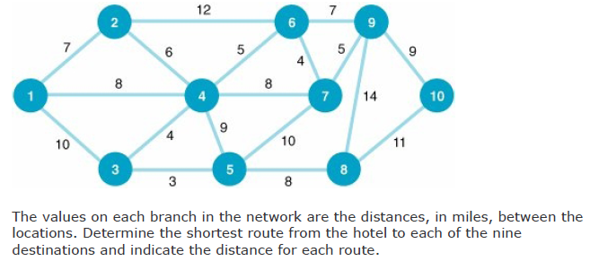

**Minimum Spanning Problems**

1. The management of a new constructed compound of large apartments is considering a walking track that will connect all the blocks and buildings of the compound. The management hopes the local citizen of will use the path or track to reach all the required facilities of the compound in a way that may reduce traffic. These are the paths or tracks in minuets taken to reach each.

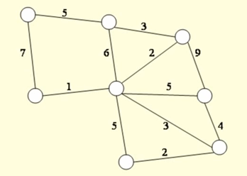

1. Several oil companies are jointly planning to build an oil pipeline to connect several southwestern, southeastern, and mid-western cities, as shown in the following network:

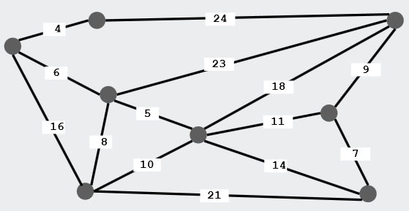

The miles between cities are shown on each branch. Determine a pipeline system that will connect all 10 cities, using the minimum number of miles of pipe, and indicate how many miles of pipe will be used.

**Maximum Flow Problems**

1. Given the following network, with the indicated flow capacities along each branch, determine the maximum flow from source node 1 to destination node 10 and the flow along each path:

**5**

5

2

**6 6 6**

6

4

3

1

**20 6 30**

12 8 8

9

1. A company owns a factory located in city S where products are manufactured that need to be transported to the distribution center city T. You are given the one-way roads that connect pairs of cities in the country, and the maximum number of trucks that can drive along each road. What is the maximum number of trucks that the co. can send to the distribution center?

V

**7** **5**

S

T

**8**

W

**9 7**

**10**

**6 6 5**

U

**7**

Z